Common SQL Server Problems

- Common Problems in Installation:
- Sometimes sql server gives an error in installation but when you try to reinstall again, it installs normally.
- If your windows needs to update and restart, do that before installation.
- Install SQL Server first then the Management Studio, otherwise you will need to browse the server.
- If the server doesn't connect normally, choose any authentication method from the dropdown menu, then switch it back to Windows Authentication.

- Cannot create a new database:
Solution: run as administrator (the SQL Server management studio).
- When you re-save an edit in a table design in SQL Server:
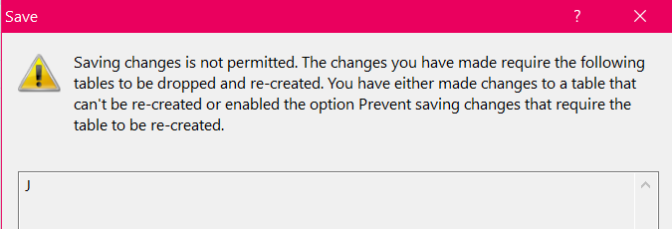
Solution: Tools -> Options -> Designers (from left pane) -> Uncheck “Prevent saving …”
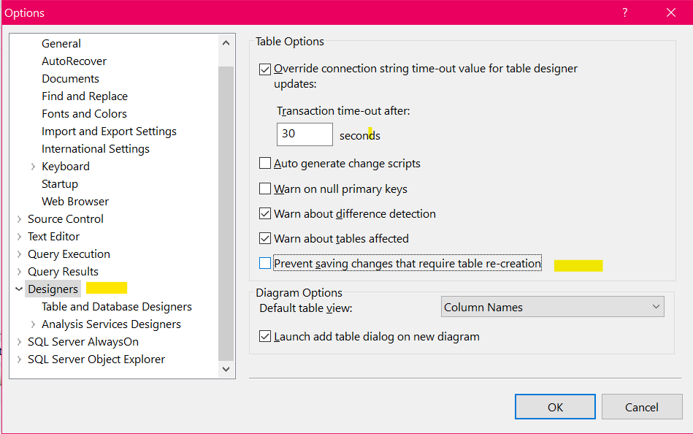

- When you save an edit in a table design in SQL Server:
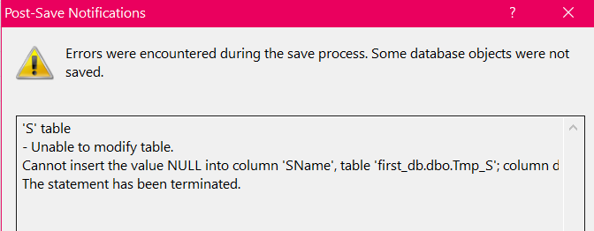
Solution: This means you entered data rows before to this table, and this design change violates the existing populated data. Modify the existing data first to satisfy this design update, then update and save.
- When you try to create new diagram but an error appears and does not create any diagram, check figures below

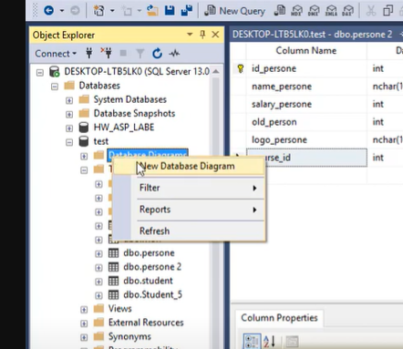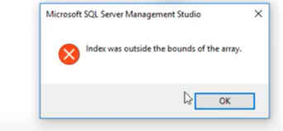
solution: simply restart the SSMS :)

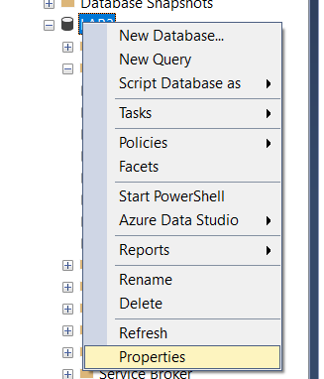
- When you try to create a new digram but a different error appears different to the one in the 5th points, and you have tried to run the SSMS as administrator (The error is related to the current user (PC’s name)).
Sol: change the owner to ‘sa’ by right clicking on the db and select properties, then change the highlighted box.

